**FLAPPY MAN !**

Name : Fernandha Dzaky Saputra

ID : 2201802922

**INTRRODUCTION**

Flappy Man is a game. It’s objective is to dodge walls by flying or jumping . The Player will always fly to the left and by pressing the key the player will jump in the air. There are two modes in this game, Single Player mode and Multiplayer mode. In Single Player mode there is only one player that will appear on the screen and in Multiplayer mode there are two players that will appear on the screen.

**DESIGN**

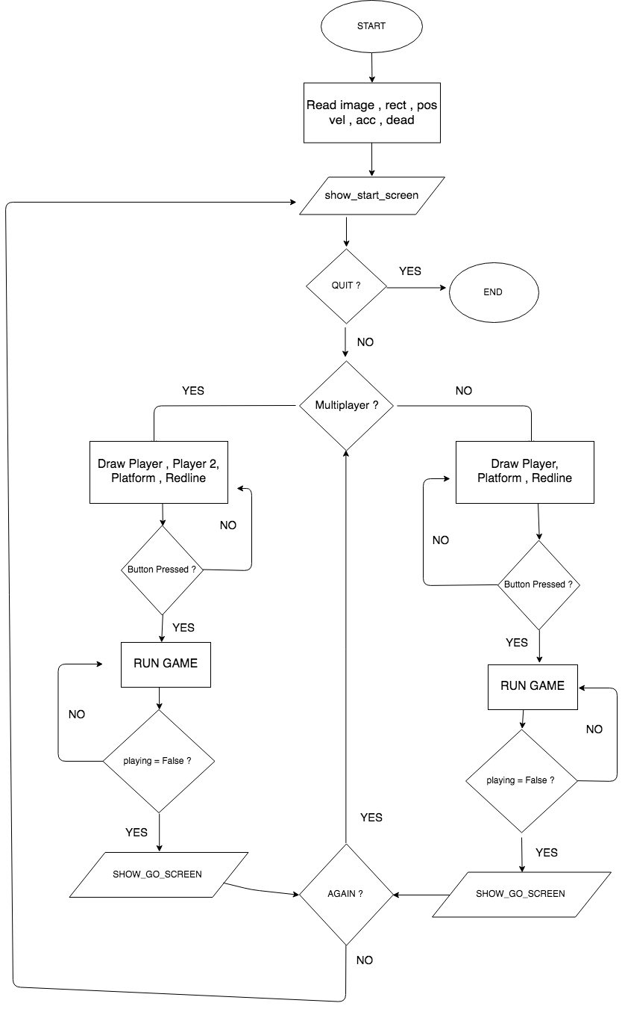 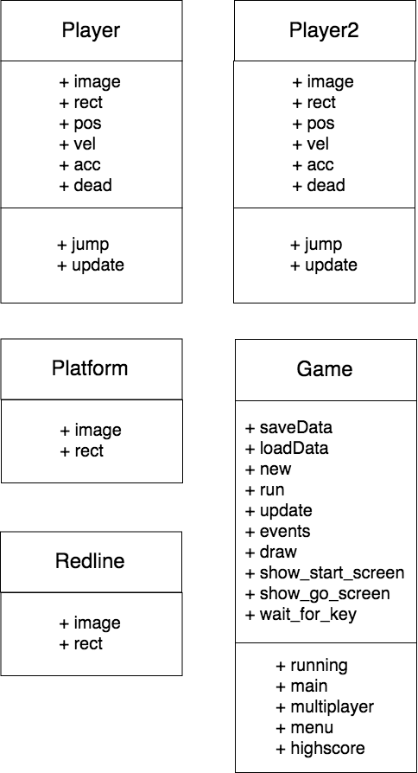

**DISCUSSION**

Modules or APIs

The Modules that are included as well as implemented / imported to the program include :

Pygame and Random.

* Pygame is the main framework that is used / implemented in this project . The module not only enables images to appear on the screen however it also creates game loop, movement of the character and also creating game function.
* Random is used to draw the walls on the screen randomly . This game needs to have random walls to make it more challenging to play . This module will draw random walls by random positions on the screen and also draw walls with random height.

Why I Choose This Project

The main reason I created this game is because nowadays people play games not just to refresh their minds but also to compete with another. That’s why I created a game that is difficult to beat, challenging , competitive but also fun altogether.

Gameplay

The objective of Flappy Man is to achieve score as high as possible. Everytime the player passes through the randomly generated wall, the player will get 1 score. In this game there are two modes that can be played , Single Player and Multiplayer mode. In Single Player mode by pressing Space Bar the player will jump in the air while still flying to the left, and in Multiplayer mode by pressing the Space Bar the 1st Player will jump and by pressing ‘A’ key the 2nd Player will jump in the air while still flying to the left. If the Player hits the wall or pass the bottom or top of the screen the game will be over.

How it Works

As shown in the Design / Flowchart above, when the program starts, it will show the Menu Screen and the player can select whether they will play in Single Player mode or Multiplayer mode.

If player select Single Player mode , the program will only draw 1 player on the screen and the screen will wait for ‘Space’ key to be pressed , if it is pressed then the character will start flying to the left direction. If player select multiplayer mode , the program will draw 2 players on the screen and will wait for ‘Space’ Key or ‘A’ key to be pressed and if it is pressed, the game will start.

While the game is playing , it will check constantly whether the rect of the player collide with the rect of the wall or the y coordinate of the player pass the bottom or top of the screen, if it does then the game will be over and the program will draw a game over screen. The player can press Enter to play again and press Back Button to go back to the Menu Screen.

While the Game runs everytime the program draw walls, it also draw at the same time an invicible red line and if the player collide with the red line it will add the score by 1. If the player achieve a high score then the score will be saved in txt file and when the player re-run the game the highscore txt file will be loaded as well.

**EVIDENCE**

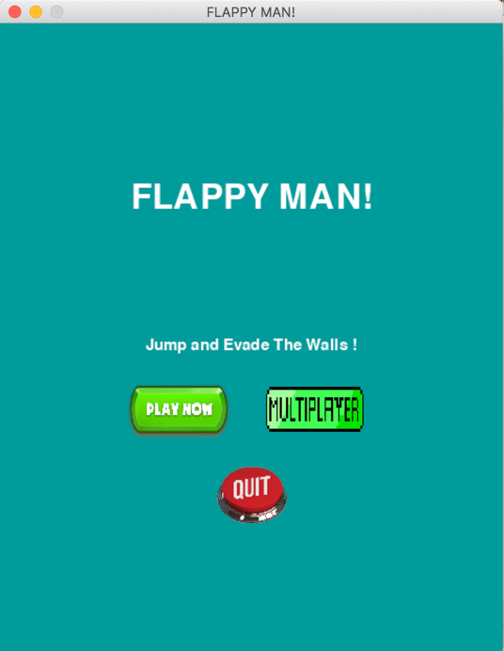 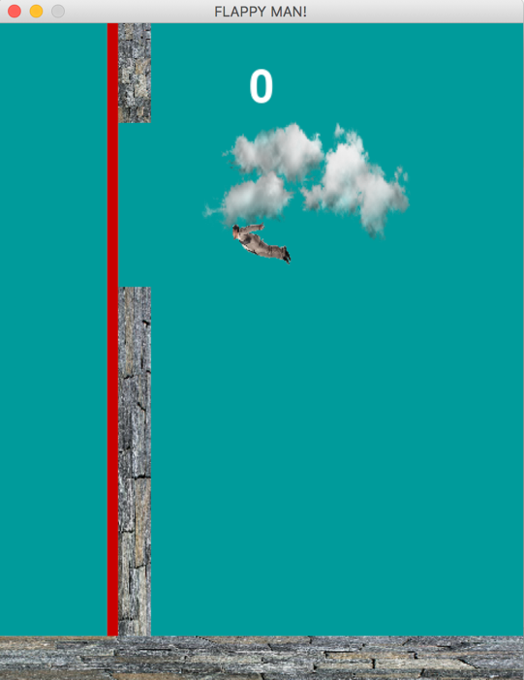

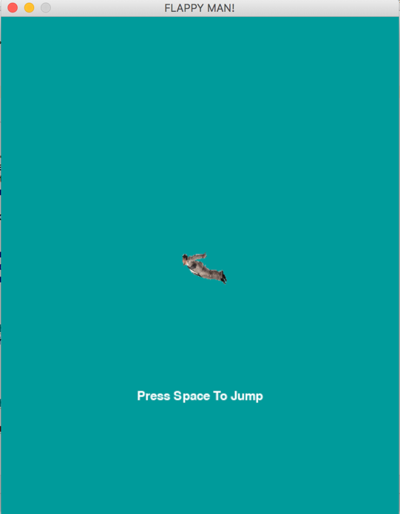 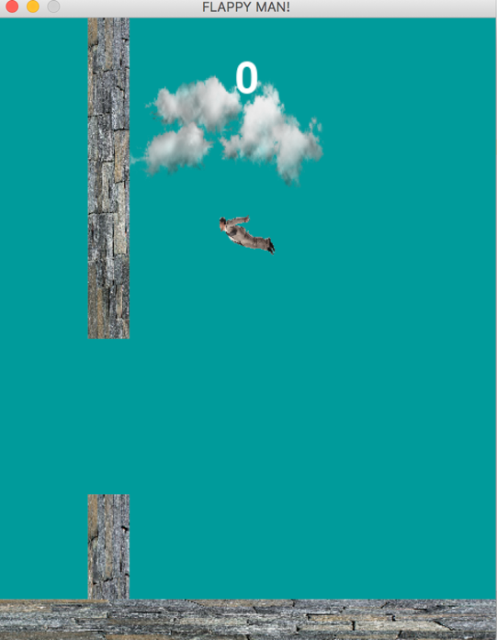

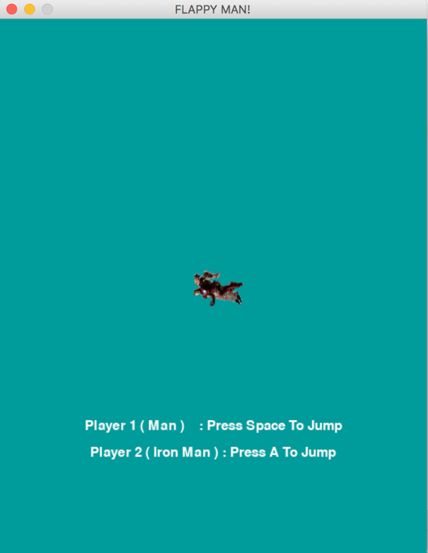 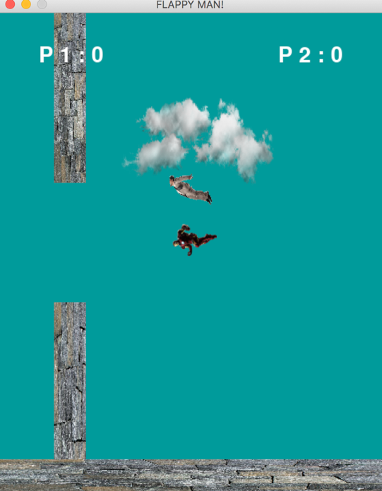

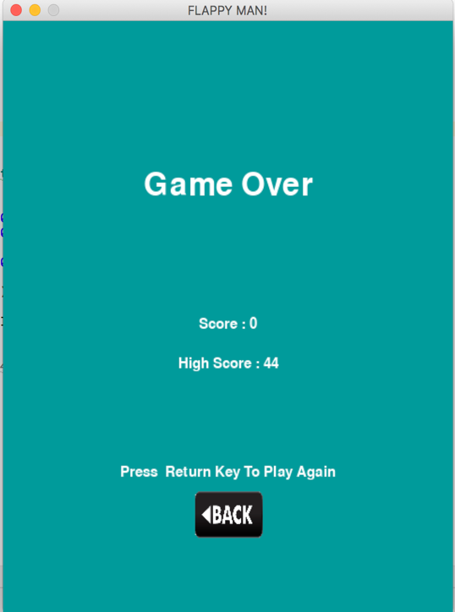 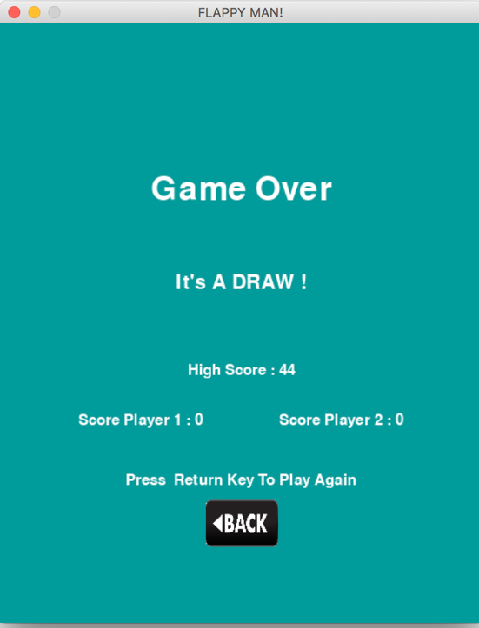

**REFERENCES**

* For Moving Screen :

<http://kidscancode.org/lessons/>

* For Images / Sprites :

<https://www.google.com/>

<https://www.pygame.org/>

* For Jumping :

<https://www.youtube.com/channel/UC4JX40jDee_tINbkjycV4Sg>

* Debugging :

Muhammad Erizky Suryaputra